**Evidence for Project Unit**

Ryan Forgie

Cohort 15

**P- 1 Github Contributors page**

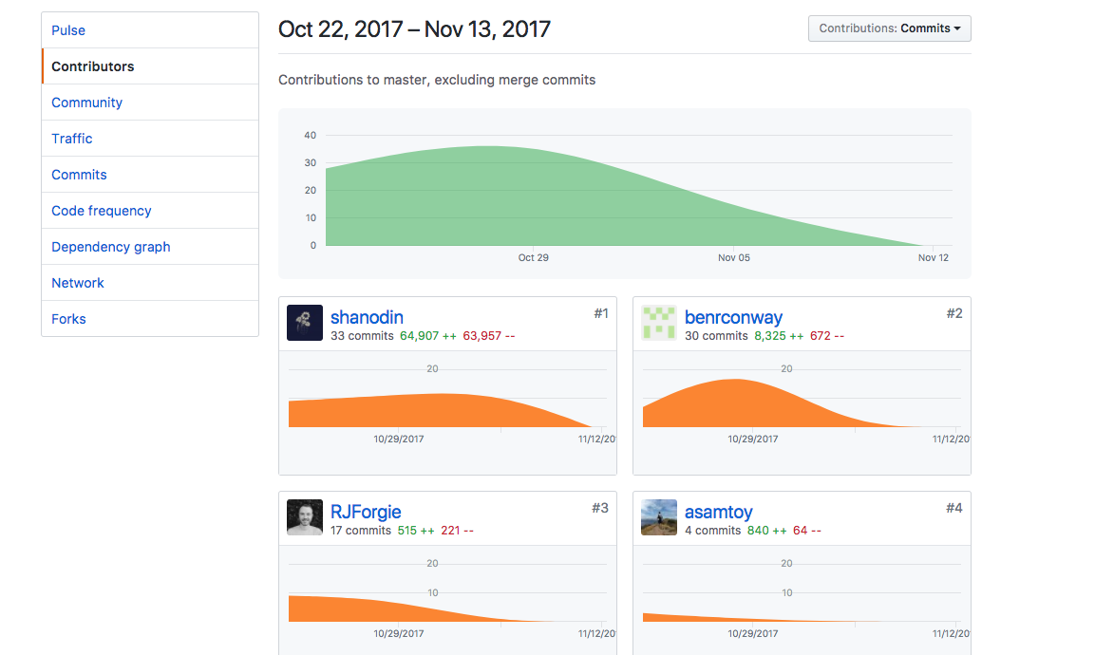

**P- 2 Project Brief**

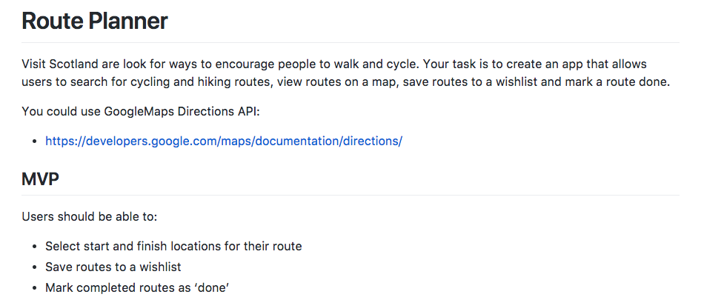

**P-3 Use of Trello**

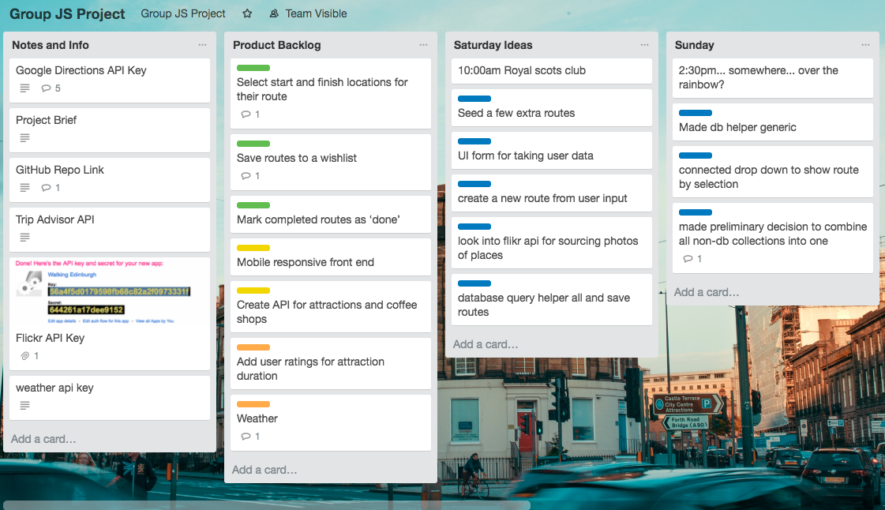

**P-4 Acceptance Criteria**

|  |  |  |
| --- | --- | --- |
| **Acceptance Criteria** | **Expected Result** | **Pass/Fail** |
| **User can enter a start and finish location for their route** | **When user enters route start and finish into autocomplete test boxes, these are assigned to new route** | **Pass** |
| **User can save routes for later viewing** | **User can create a custom route then click a save button and the route is added to the routes dropdown** | **Pass** |
| **User can click a marker and see more information on that attraction** | **User clicks marker and the name of that attraction is displayed on top of map** | **Pass** |
| **User can see today’s local weather** | **Today’s weather in Edinburgh is displayed to user in text and icon form** | **Pass** |
| **User can view photos of each attraction** | **Marker info windows will display a photo of the attraction pulled from Flickr when user clicks map marker** | **Pass** |

**P-5 User sitemap**

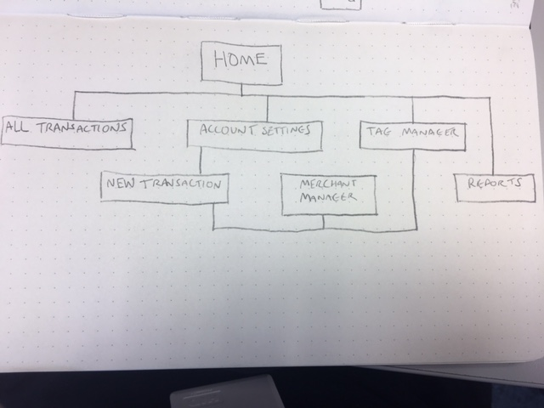

**P-6 Wireframes designs**

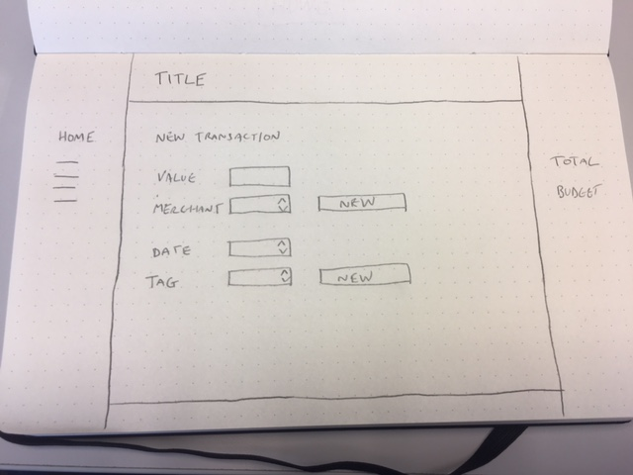

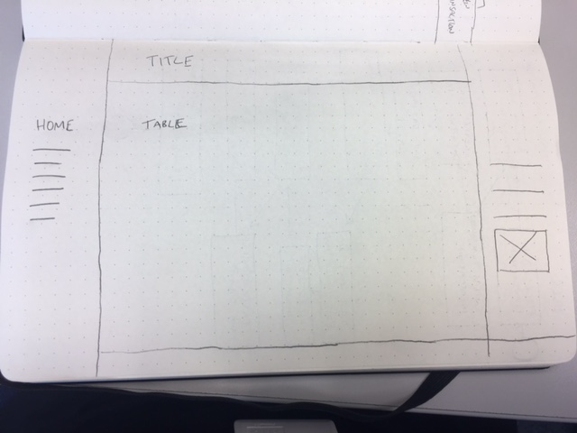

**P-7 System interactions diagrams**

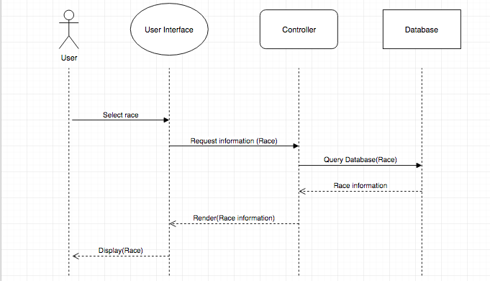

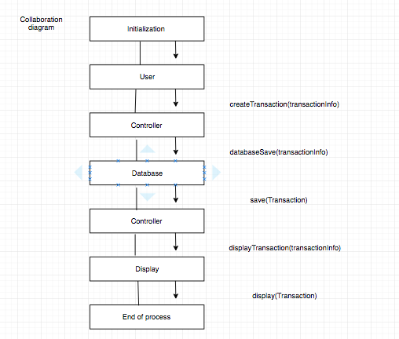

**P-8 Two Object Diagrams**

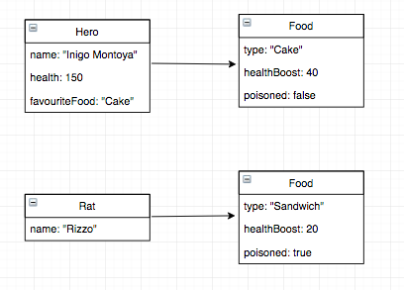

**P- 9 Algorithms**

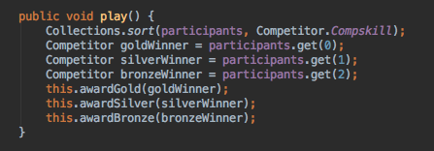

This algorithm had the purpose of working out which competitor had won an event and then correctly allocating Gold, Silver and Bronze medals. It does this my sorting the arraylist of event participants be their skill level, with the gold winner ending up in position 0, silver winner in position 1 and the bronze winner in position 2. It then calls helper functions for each position to allocate the correct medal.

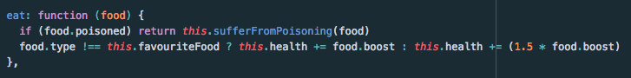

This algorithm had the purpose of detecting if a Hero had eaten poisoned or non-poisoned food and modify hero health accordingly. The If statement checks if the food poisoned Boolean is true, if so it calls the helper function ‘sufferFromPoisoning’ to lower Hero health. The algorithm then uses a switch statement to check if the food is NOT the hero’s favourite food and if so then it boosts Hero health by the food’s boost value. The other side of the switch checks if the food is the equal to the Hero’s favourite food and if so then raises Hero health by 1.5 times the food’s boost value.

**P - 10 Example of Pseudocode**

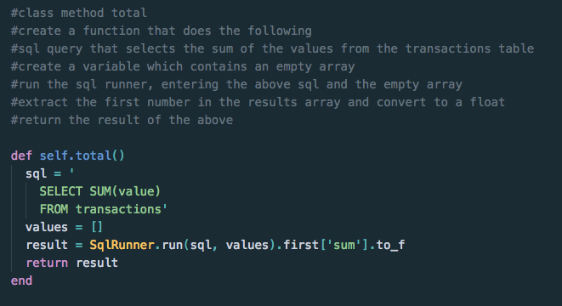

**P - 11 Github link to one of your projects**

[**https://github.com/RJForgie/Project-Java-Run-List**](https://github.com/RJForgie/Project-Java-Run-List)

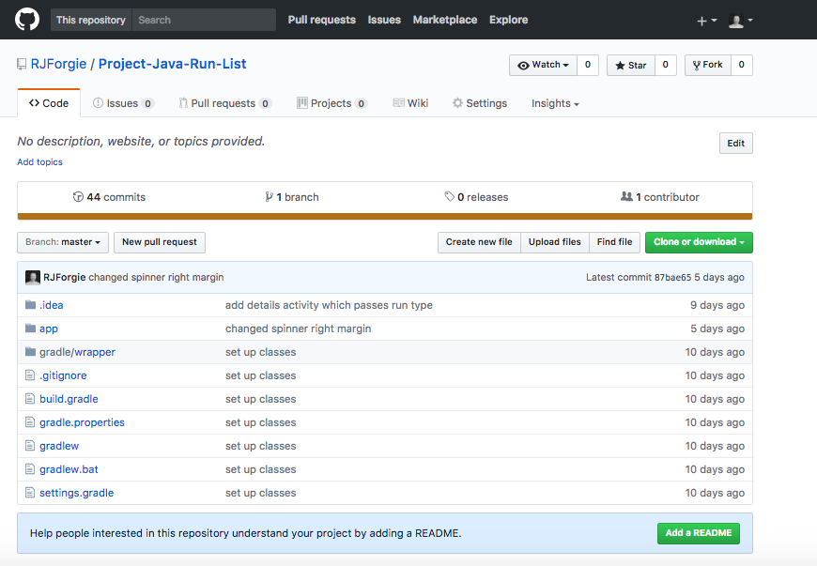

**P - 12 Screenshot of your planning and the different stages of development to show changes.**

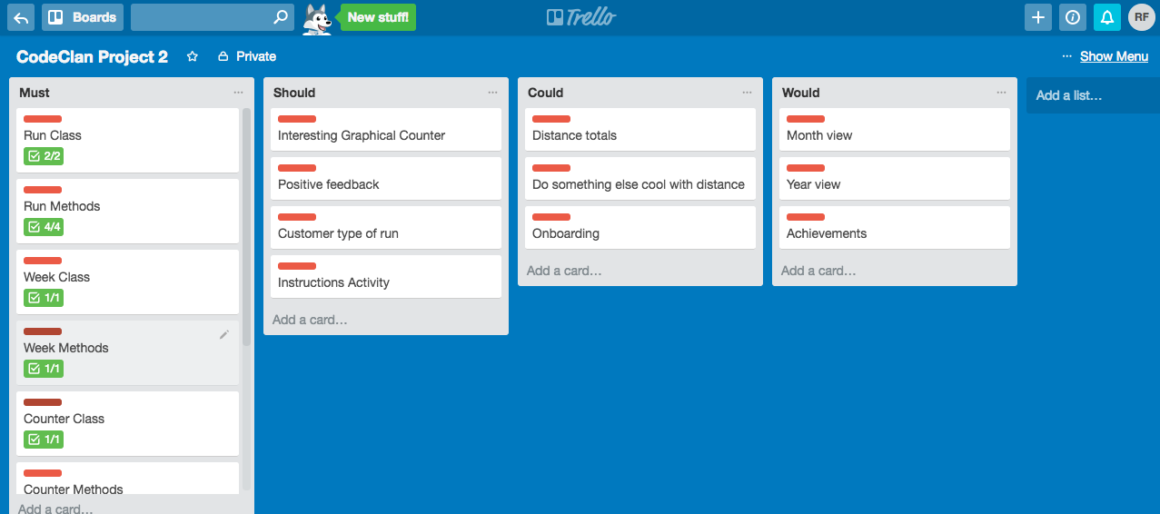

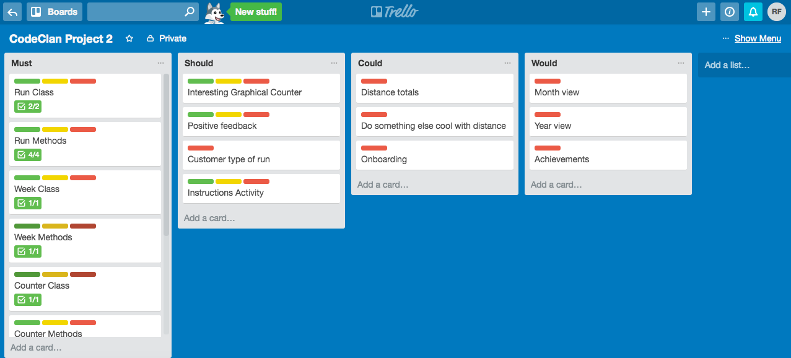

**P - 13 User input**

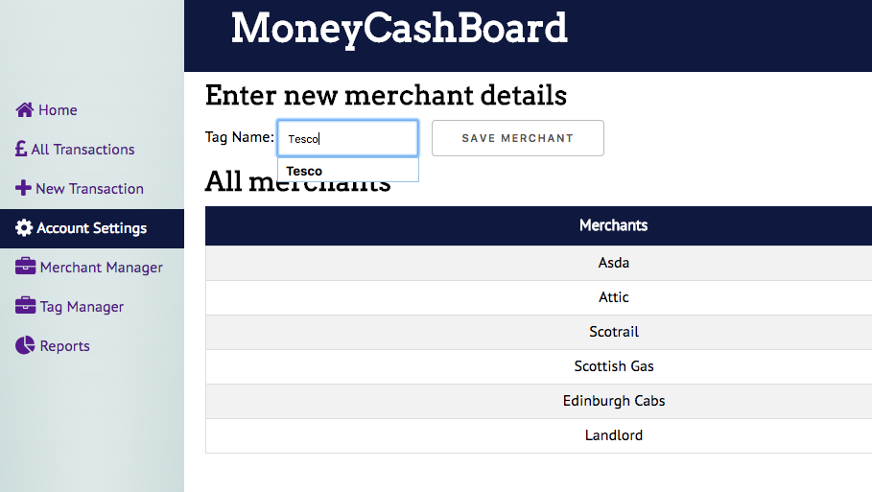

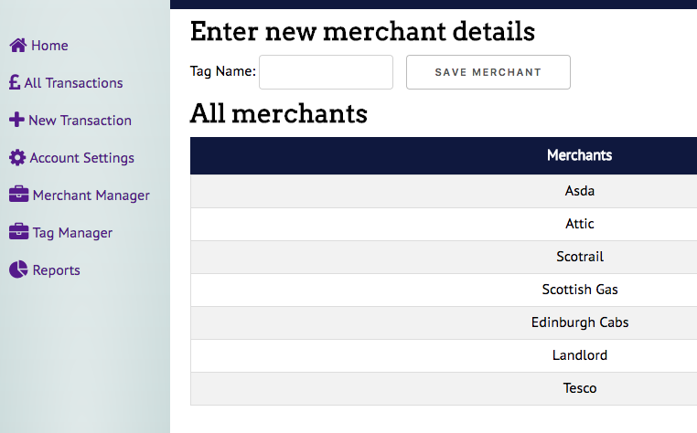

**P - 14 Interaction with data persistence**

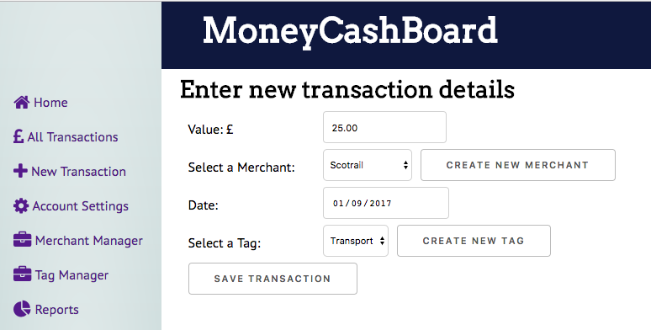

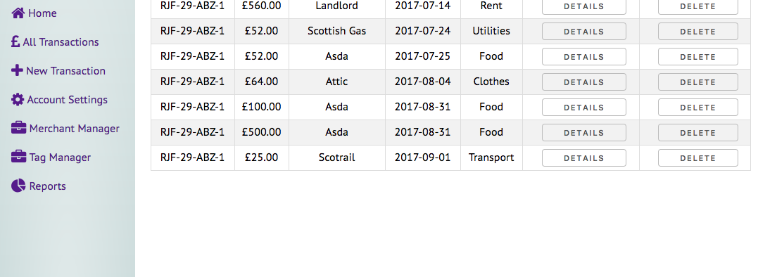

**P - 15 User output result**

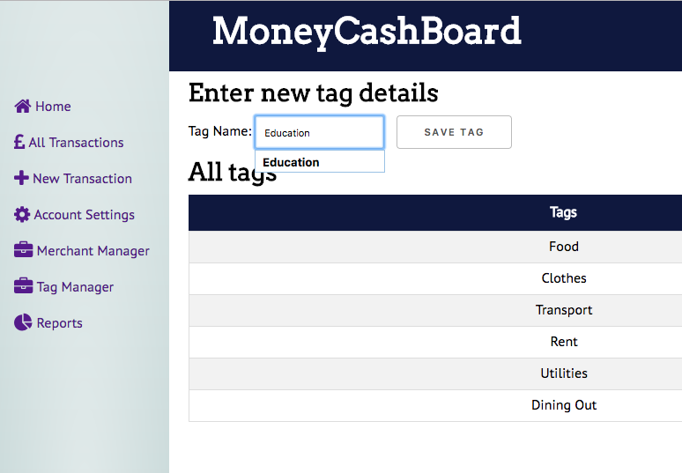

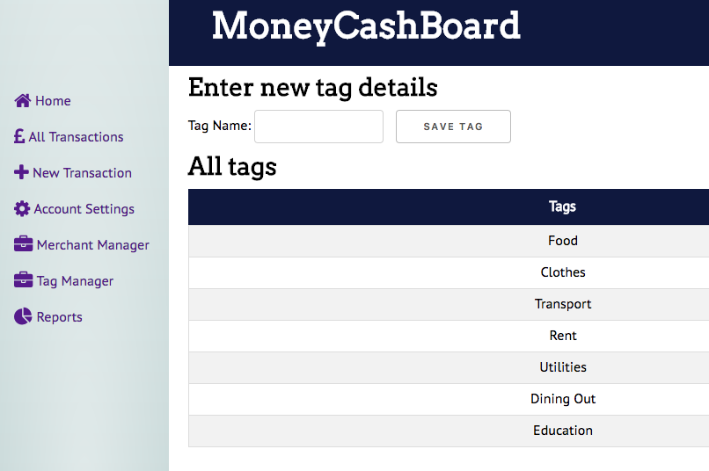

**P - 16 Use of API**

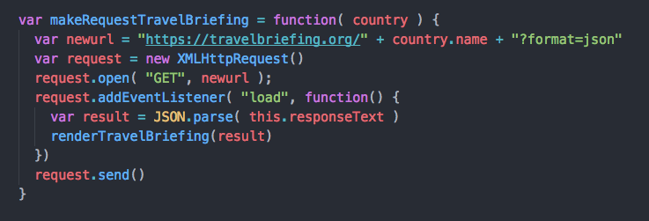

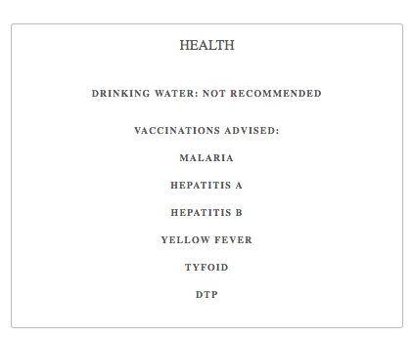

**P - 17 Bug tracking report showing the errors diagnosed and corrected.**

|  |  |  |  |
| --- | --- | --- | --- |
|  |  |  |  |
| **User must be able to add a new route and display it** | **Failed** | **New route was saving but not displaying. Changed renderRoute function to display custom routes** | **Passed** |
| **Route has a start and end point** |  |  | **Passed** |
| **InstaEdinburgh route not displaying** | **Failed** | **Identified invalid latitude and longitude in route seed data and fixed** | **Passed** |
| **Correct size photo should display in Google Map info window** | **Failed** | **Change Flickr API request to obtain correct size image** | **Passed** |

**P -18 Testing your program**

